Wish List Tips

- Tell or show supporters why you're asking.
- Share your list regularly, and ask for specific items that are needed.
- Put a link to your wish list on your website.
Note: Many shelters are turning to Chewy for their wish lists, or offering the choice of an Amazon or Chewy wish list. You can read more about the Chewy Shelter and Rescue Network and their wish list program.

How to Create an Amazon Wish List

Create a wish list that your supporters can use to find out what you need and make in-kind donations.
To create a List:
- Sign in to your Amazon account.
- Click on Account & Lists. When the panel pops up, under Your Lists, select Create a List.
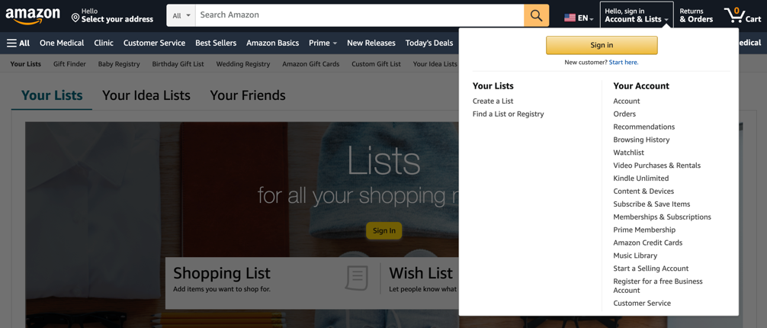
- Give your list a name.
- Select Create List.
- Click on the three dots menu, and then click on Manage List. 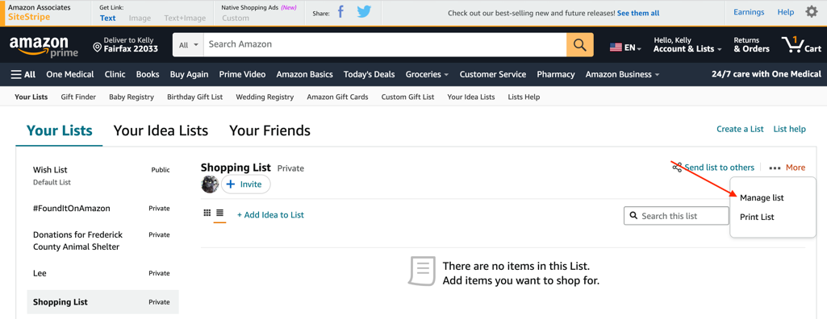
- Update your shipping address and other preferences.
  - If this is a wish list for a shelter or rescue organization, make sure to set it to Public.
  - If you’d like the items shipped directly to your organization
    - Fill in your shipping address
    - Click the box next to Share my shipping address with sellers. If this box isn’t checked, the donor will need to have the items delivered to their own home and find a way to bring them to you.
- Select Save Changes.
You can repeat this process to create an unlimited amount of lists.

To add items to your wish list, select Add to List on any item's product details page. Then choose the list you’d like to add it to. 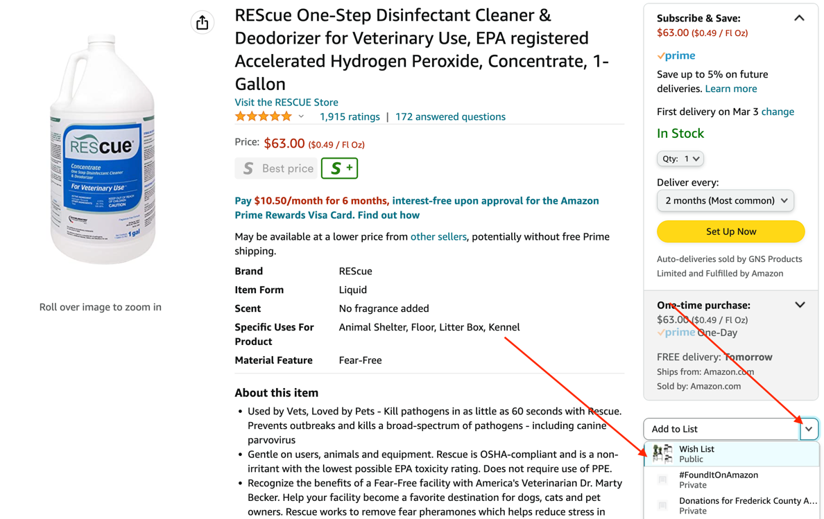

Notes:
- Only list owners can make changes to lists.
- Gift givers only see the name, city, and state of your address.
- Amazon only uses your birthday for birthday reminders, and to provide information on the site.
- You can update your information any time.
- Items are added to your default list when you select Add to List. For more information, see Edit Items in Your list.
- Both list owners and invited people can add items to lists.
- You can add items for sale by Amazon to your list, except the following:
  - Out-of-print books
  - Out-of-stock products
  - Cell phones with service plans
  - Items without release dates
  - Items with quantity restrictions
- You can add items from sellers to your list. We'll display See Buying Options instead of Add to Cart on the product details page, because the same item may not be available later.
- You can indicate which items are the highest priority, make notes for donors about the products you’re requesting and let donors know how many you need by viewing your wish list and clicking on Add comment, quantity & priority.
