Pathway Planning

Purpose:
This document provides an overview to guide pathway planning in ASPCA programs that intake unowned animals.

Responsibilities:
Population Rounds Team – these rounds are the core platforms for pathway planning conversations – representatives contribute to a holistic perspective on the animal, placement prospects, and the shelter population as a whole.

Definitions:
Critical Flow-Through Points – represent some type of care or an action/event that must occur for an animal to continue along a pathway towards an outcome. Examples include but are not limited to veterinary examinations, vaccinations, behavior assessments, legal holds, and spay/neuter surgery. Reference specific SOPs for detailed processes.
Pathway Planning – the process of actively tracking and guiding each animal’s shelter stay from the moment they enter the program to the moment they leave. Each animal should be thought of as on the road to an outcome starting at the point of intake, so that each next step can be anticipated, scheduled, and completed on time.
Population Management – an active process of planning, ongoing daily evaluation, and response to changing conditions as a program cares for multiple animals. Effective population management requires a plan for intentionally managing each animal’s stay that takes into consideration the program’s ability to provide care in accordance with the Association of Shelter Veterinarians Guidelines for Standards of Care in Animal Shelters.
Population Rounds - cross-team rounds, such as MBS or Foster rounds, that ensure that each animal in our care has a planned pathway based on up-to-dateobservations and information and is not waiting needlessly for any critical flow-through points or decisions.
Outcome Criteria – physical, behavioral, legal, and/or environmental characteristics that must exist for an animal to be eligible for a particular pathway and outcome. Reference treatment and adoptability guidelines and centralized placement protocols for additional details.

Pathway Plan Process:
- Pathway Designation
  - A pathway is designated for every animal at the time of intake to guide current and future planning.
  - A legal hold should not prevent the designation of a pathway, but it may delay certain critical flow-through points until the hold is lifted.
  - If the most likely outcome is not clear at intake, the default pathway should be adoption/placement. Pathway designation is fluid –
it can be changed as more information is obtained or as program/case circumstances change
  - The pathway should be recorded (and updated appropriately) in a consistent location, such as the animal’s record or a population rounds tracking form, so the current pathway is clearly communicated.
- Pathway Monitoring
  - The animal’s pathway should be reviewed regularly as part of population rounds (refer to Population Rounds SOP). This allows the team to review available information and determine if the current pathway is appropriate or if it needs to be adjusted.
  - It is important for the Population Rounds participants to have enough insight and decision-making authority to create and follow-up on action plans developed during rounds. However, depending on the program, the specific animal, and any unique circumstances, changes to pathway designations may require further discussion with or approval by department leadership, subject matter experts, or critical stakeholders. These additional discussions should be an exception to the process and not a regular occurrence; decision-making authority should primarily belong to the Population Rounds team. When monitoring the pathway, the population rounds team should ensure progress is being made towards that outcome and proactively schedule next steps.

Pathway Plan Flowchart:
This chart outlines critical flow through points and important aspects to consider when evaluating the pathway of an individual animal within an ASPCA program.

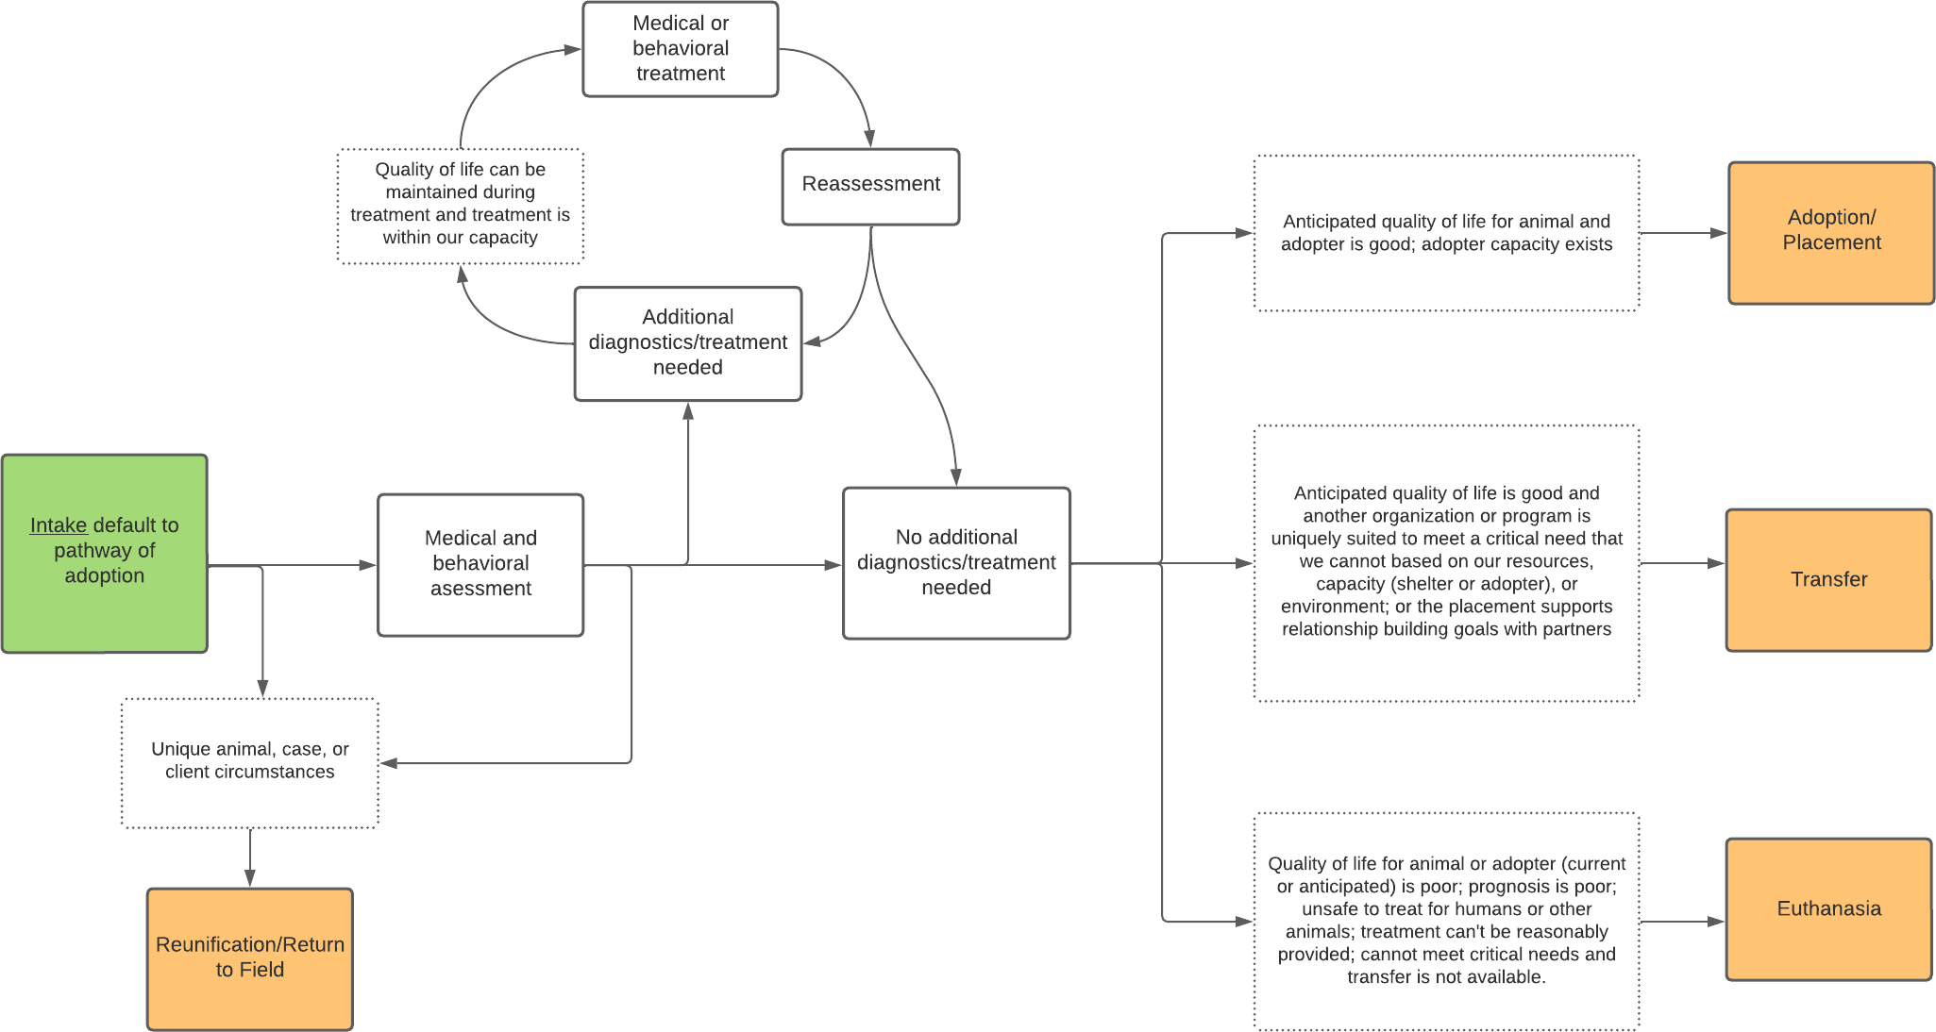

Foster Care Flowchart:
While foster care is not an ultimate outcome, it can be a critical and/or highly beneficial temporary outcome along the pathway. This chart should be utilized as part of the pathway planning process to determine whether on-site care or foster placement is most appropriate for each animal.
