**PANLEUK WARD TECH GUIDE**

**(DRAFT - 5/19/2019)**

Revised 06/02/2020

* **Copy of Panleuk Tech Task List (Feb 2019) 8th**
* **Copy of Panleuk Technician Job Description (2018)**
* **Intake**
* **Medications**
* **Care and Maintenance**
* **Exit**
* **Supplies**
* **Common Terms**
* **Historic Misc. Items**

**Copy of Panleuk Tech Task List (Feb 2019)Copy of Panleuk Technician Job Description (2018)**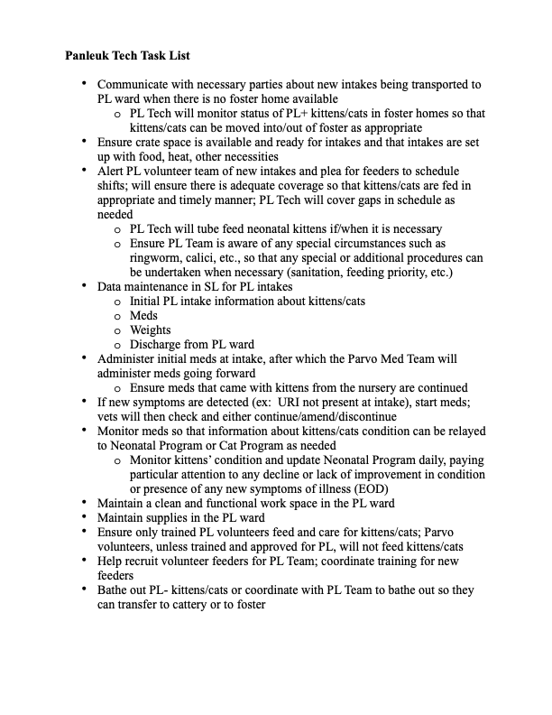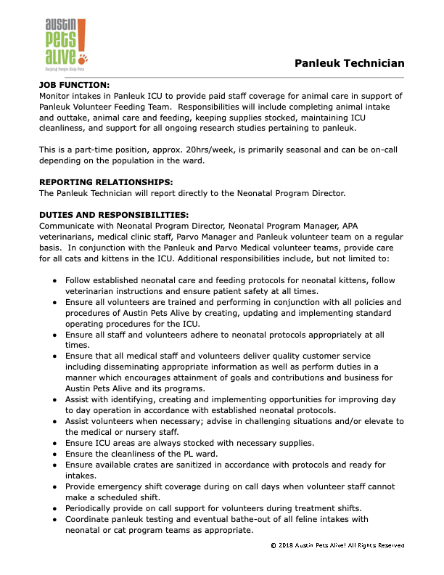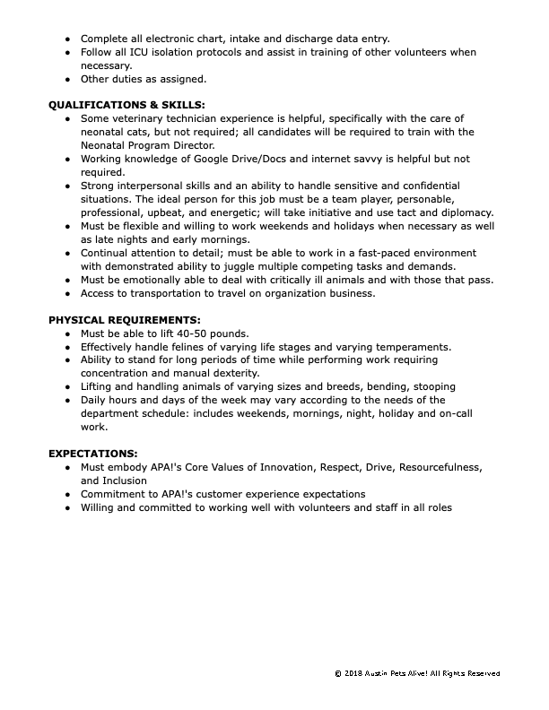

**INTAKE**

The **Clinic or Nursery**, depending on where the kitten enters APA! care, should **verify a positive Panleuk test before the kitten goes into the PL ward**. Once in the PL Ward, the kitten (positive or not) must go through the Panleuk protocol for a minimum of 5 days. After 5 days in the PL Ward and a negative Snap test, the kitten can leave the Ward.

1. Receive the kitten and make sure it has an accompanying ***APA! Parvo Ward Intake Form***
2. Set up a cage
3. Weigh, place in cage
4. Fill out ***Parvo Treatment Sheet***
5. Fill out ***Daily Care Sheet***
6. Draw and prepare meds as prescribed on the ***Parvo Treatment Sheet***
7. Administer meds
8. Feed or force feed if needed/necessary using the ***Daily Care Sheet***

Although litters are placed in the same cage (or split if a large l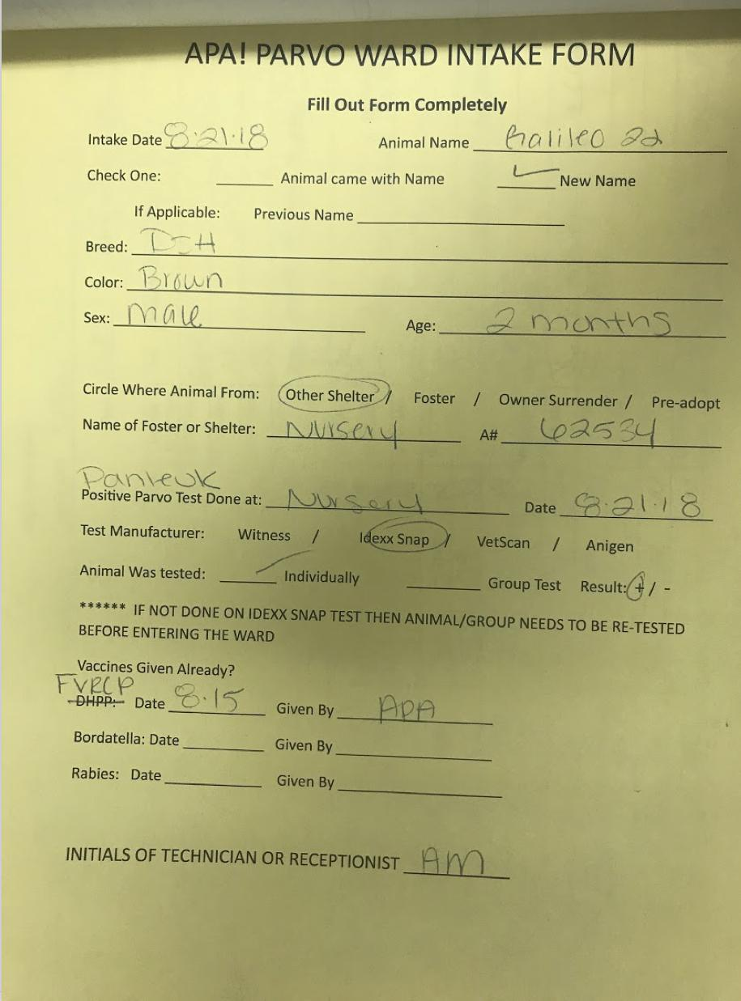itter), each kitten must have its own *Treatment* and *Daily Care* sheet.

**1. Receive the kitten**

When a litter enters the PL Ward, it will be in a travel carrier or disposable cardboard carrier. After intake, the travel carrier needs to be thoroughly cleaned and sanitized, and placed near the back of the Parvo Ward for removal. Disposable carriers are handled under the Parvo Ward’s trash protocols.

Bedding in the carriers can either be laundered and remain in the Parvo Ward or disposed of in the trash. If the bedding is (excessively) soiled or worn, throw it into the trash.

Each kitten or cat should be accompanied by an ***APA! Parvo Ward Intake Form****.* This form is filled out by the APA Clinic. The PL Ward copy is yellow. If there is no form, ask the Clinic. This form contains important information you will need and is part of the kitten’s Shelter Love (SL) data. This form, along with the **Treatment** and **Care Sheets**, will be scanned and entered into SL. If the kitten has an ***Intake Form*** then it should also have a file in SL.

**2. Set up a cage**

Kittens with additional **contagious diseases** (Calici, Ringworm) should go on the **bottom row** and be separated from other kittens as much as possible. A **warning sign** should be placed on these cages noting the additional disease.

Large litters or a mom with kittens can be put in one of the larger pop-up crates on top of the cages. Large litters can also be separated. Additional pop-up crates may be needed if cages are all occupied. Additional pop-ups are on top of the cages in the very back Parvo room (past the toilet). Additional crates may have to be placed on the floor and/or stacked on top of each other to accommodate all intakes.

* **Bedding**
* **Heating pad** under bedding set to ‘low’.
* **Bowl of water**
* **Bowl of Kibble** (dry kitten food), 1/3 full
* **Warm plate of gruel** for kittens, warm wet food for older kittens and adults eating regular wet food
* **Box of non-clumping litter**
* **Toy** (optional)

**3. Weigh, place in cage**

Be sure to write down the weight, name AND description of each kitten so care sheets can be prepared easily without having to re-weigh and identify kittens.

Weigh each kitten before placing into cage to:

* Establish a weight for the **Care** and **Treatment** sheets
* Determine if kitten has eaten in cage for next shift

**4. File out *Parvo Treatment Sheet***

Each kitten will have its own **Parvo Treatment Sheet**. This sheet will stay with the kitten through its entire stay in the PL ward. Anyone treating the kitten (vet, parvo, pl) will refer to this sheet for administering treatment, adding treatment, discontinuing treatment and care/concern notes.

Accurate dosing for all medication prescribed is very important and should be double checked.

Keep all sheets for entire cage on one clipboard.

The vet on duty will make rounds during the day and refer to the **Treatment** and **Daily Care** sheets. The vet may add or discontinue some medications. It is important to review the sheets for any changes made by staff or noted by volunteers.

**Parvo Treatment Sheet:**

* Name/Description: Animal name and description used on the **APA! Parvo Ward Intake Form**. Include Clinic/Nursery applied (to head or ears) color markings to help distinguish litter mates. Include the APA #.
* Weight: The weight taken on Intake before placing in the PL Ward cage. List both the weight in grams (g) and pounds (lbs). Weight must be converted to lbs for medication dosage calculations.
* CAUTION: If kitten has other contagious condition, i.e. ringworm, calici.
* Add cage number to the top of the form. Cage number will be included in ShelterLuv.
* Date AM PM: Start with date and time of day of first administered medications. Fill in dates for the remainder of the treatment.
* Physical Exam: During treatment, note kitten’s condition as listed. This exam should be completed for AM and PM regardless if medications are given or not given for both the AM and PM.
* Medications: Refer to the **Medications** on the following pages for Panleuk specific medications, dosage, and duration.
* Intake and Output: During treatment, note kitten’s intake (eating, drinking) and output (litter box, vomit, etc).
* (Notes): List any concerns and observations that could/should be addressed by the vet.



**5. Fill out *Daily Care Sheet***

Each kitten will have its own **Daily Care Sheet**. This sheet will stay with the kitten through its entire stay in the PL ward. Anyone feeding the kitten will use this sheet for recording time of feeding, weight, amount fed, output, and any comments/notes.

Keep all sheets for entire cage on one clipboard.

The vet on duty will make rounds during the day and refer to the **Treatment** and **Daily Care** sheets. The vet may add or discontinue some medications. It is important to review the sheets for any changes made by staff or noted by volunteers.

**Daily Care Sheet:**

* Name: Animal name
* Description: Animal description used on the **APA! Parvo Ward Intake Form**. Include Clinic/Nursery applied (to head or ears) color markings to help distinguish litter mates.
* Sex: Sex
* A#: The APA # as found on the **APA! Parvo Ward Intake Form**
* Admin date: Intake date as found on the **APA! Parvo Ward Intake Form**
* Age: Age as found on the **APA! Parvo Ward Intake Form**
* Admin Weight: The weight taken on Intake before placing in the PL Ward cage. This will be the same weight that is on the **Parvo Treatment Shee**t.
* Add cage number to the top of the form. Cage number will be included in ShelterLuv.



**6. Draw and prepare meds using *Parvo Treatment Sheet***

Meds are prepared in Parvo on the counter with all the medical supplies. Keep the ***Parvo Treatment Sheets*** with you so you can read and refer to them constantly. They can be carried anywhere in the PL and Parvo Wards, but all paper work must remain in the Wards. Refrigerated meds will be in the large refrigerator. It is best to prepare meds when Parvo is not preparing their meds. Space and availability of meds can become an issue along with possible mistakes from an over-crowded area.

Use whatever method works best to keep meds for multiple kittens separate; different color stickers for each kitten on all syringes, labeling syringes with sharpies, etc.

Do not use the larger gauge needles on kittens.

The Neonatal Nursery method for SubQ meds is for each med to be given separately to each kitten; do not combine all SubQ meds into one syringe for each kitten.

The Parvo staff may administer meds and fluids slightly different. ***The Panleuk Tech is under the supervision of the Neonatal Program and should follow the Neonatal procedures and protocols.***

**7. Administer Meds**

Return to the PL Ward to administer meds and fluids. Be sure not to mix the syringes and meds together from different kittens. It is best to give each kitten all their meds at one time so as to not handle them multiple times. You may have to wrap them in a way to keep them from moving/escaping or ask for assistance to hold uncooperative kittens.

*ANY NEW MEDS ADDED TO TREATMENT WHILE KITTENS IN THE WARD NEED TO BE ADDED TO SL BY PANLEUK TECHNICIAN*

**8. Feed or FF using *Daily Care Sheet***

If enough time has passed so the SubQ fluids are not affecting the kitten’s weight (15-30 min) and time allows, feed the kitten. By taking the next shift on the ***Daily Care Sheet*** (after intake), you can establish the feeding method for the kitten whether it be force feeding (SG) or eating on their own (G).

Do not leave it up to the volunteer feeder to determine if the kitten may be eating on its own when the feeding chart does not specifically indicate the kitten is a gruel kitten.

**MEDICATIONS:**

These are the medications given to a kitten/cat on intake into the PL Ward.

* **Baytril** - 0.02cc / lb, SID SQ x 5 days (ALWAYS in SQ fluids)
* **Polyflex** - 0.05cc / lb, BID SQ x 5 days
* **Cerenia** - SID SQ x 5 days (FOR VOMITING)

<1.0 lb -- 0.05 cc (less than a pound, give 0.05cc)

1.0-2.0 lb -- 0.10cc (1 to 2 pounds, give 0.10cc)

>2.0 lb -- 0.04 cc / lb (if more than 2 pounds, give 0.04cc per pound)

*May redose if vomiting persists (2 doses per 24hrs max)

* **LRS** - 15cc / lb, TID SQ x 5 days
* **Marquis** - 0.2cc / lb, SID PO x 3 days
* **Panacur** - 0.2cc / lb, SID PO x 3 days
* **Fortiflora** – a pinch in warmed food per feeding – at Panleuk Tech’s discretion
* **Additional Medications** – continue medications prescribed prior to intake and any medications prescribed at vet/tech’s discretion.

**Calculations & Instructions of Medications:**

Medications are calculated in pounds (lbs).

Convert grams to pounds. (fyi: ml = cc)

**Grams to pounds: #g / 454 = lb**

Pounds to grams: #lb x 454 = g

**Baytril:** 100mg/ml, 2mg (.02) per pound of body weight SID SQ x 5 days.

# x .02cc = cc

Always in fluid pocket.

This is a tiny amount (0.02cc) less than a drop.

Do NOT overdose!

Do NOT inject Baytril directly into the skin. It will cause abscesses

**Polyflex:** 0.05cc per pound of body weight BID x 5 days

#lb x 0.05cc = cc

Refrigerate

**Cerenia:** SQ SID x 5 days – FOR VOMITING

<1.0 pound: 0.05ml

1-2 pounds: 0.10ml

>2 pounds: 0.04ml/lb

Refrigerate

Can re-dose (up to 2 doses per 24hrs) if initial dose does not resolve vomiting

**LRS:** 15cc SQ per pound of body weight TID x 5 days

#lb x 15cc = cc

**Panacur:** 0.2 ml/lb po SID x 3 days

#lb x 0.2cc = cc

**Marquis:** 0.2 ml/lb po SID x 3 days

#lb x 0.2cc = cc

**Baytril**

Baytril (Enrofloxacin) is a broad spectrum antibiotic used to treat certain bacterial infections.

Baytril is clear, sticky, and comes in a bottle that is not refrigerated. It is ALWAYS administered with subcutaneous fluids (LRS) and NEVER injected without first being diluted within the fluids. If Baytril is injected directly in the skin, it will cause abscesses.

The dose of Baytril (100mg/ml) is a very small amount (0.02 cc per lb), essentially just the hub of a syringe.

The dose of Baytril is 0.02cc per lb, SID SQ x 5 days.

The syringes in the Parvo Ward are larger than the Neonatal Nursery. It is harder to accurately measure a “hub” of Baytril in the larger syringes. Another method of adding the Baytril to the LRS syringe instead of the “hub” method as used in the Nursery, is to measure the 0.02cc/lb into a 1cc syringe and inject the Baytril in the 1cc syringe into the top of the larger syringe containing the already pulled LRS.

**Polyflex**

Polyflex is an injectable antibiotic used in the treatment of respiratory infections and other infections. 

Polyflex is white and comes in a refrigerated vial. It is an injectable and given subcutaneous. It can be injected by itself or within fluids.

The dose of Polyflex is 0.05cc per lb, BID SQ x 5 days.

**Cerenia**

Cerenia is a medication to treat vomiting. It is a non-drowsy medication that comes in two formulations—an injection, or tablets. The PL ward and Nursery use the injectable.

Cerenia is clear and comes in a refrigerated vial. This form is administered as a subcutaneous injection. Cerenia causes a burning sensation when injected. The kitten must be scruffed/restrained when Cerenia is administered because the kitten will have a negative reaction and possibly try to escape. This reaction is short-lived, but the initial reaction to the injection range from mild to severe. Negative reactions can be minimized if the Cerenia injection is given in the SQ fluid ‘hump’ of a fluid (LRS) injection.

The dose of Cerenia is:

<1.0 lb -- 0.05 cc (less than a pound, give 0.05cc)

1.0-2.0 lb -- 0.10cc (1 to 2 pounds, give 0.10cc)

>2.0 lb -- 0.04 cc / lb (if more than 2 pounds, give 0.04cc per pound)

SQ SID x 5 days

May redose if initial dose does not stop vomiting (up to 2 doses per 24 hrs)

**Marquis**

Marquis is the brand name for Ponazuril, an oral paste solution used to treat protozoal and coccidial infections. Coccidia infections are relatively common in puppies and kittens and affected pets usually present with diarrhea.

Marquis is a white suspension, not refrigerated, given orally, and sometimes in a container marked ‘Marquis’ and not in the original bottle. Marquis and Panacur look the same when drawn in a syringe. Caution should be 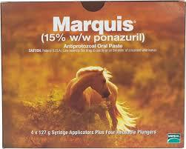taken to differentiate syringes when preparing meds for multiple kittens.

The dose of Marquis is 0.2cc per lb, SID PO x 3 days.

**Panacur**

Panacur C (fenbendazole) is a broad spectrum parasiticide used to treat hookworms, roundworms, tapeworms, and whipworms. It is also used by veterinarians to treat other parasites.

Panacur is a white suspension, not refrigerated, given orally, and sometimes in a container marked ‘Panacur’ and not in the original 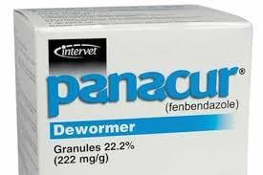bottle.

The dose of Panacur is 0.2cc per lb, SID PO x 3 days.

**LRS**

LRS (Lactated Ringers) is a sterile solution for fluid and electrolyte replenishment and administered intravenous.

LRS is a clear solution, not refrigerated, given subcutaneous, and comes in an IV bag. Since there are several types of IV bags in the Parvo ward, care should be taken in identifying the LRS bag for Panleuk use.

The dose of LRS is 15cc per lb, TID SQ x 5 days.

**Neonatal Nursery Meds for Diarrhea**

**Step 1:** Start when 24 hours or less of diarrhea (runny/watery stool)

* **Pen-G (1:6) -** SQ SID x 3 days (see intake chart for dosing)

**Step 2:** If diarrhea is not resolved on Day 3 of Pen-G

* **Panacur -** 0.2cc per pound PO SID x 5 days
* **Marquis Paste/Ponazuril**
  + (50 mg/ml) 0.3cc per pound PO SID x 5 days
  + (75 mg/ml) 0.2cc per pound PO SID x 5 days
* **Praziquantel -** (75mg/ml suspension) (see intake chart for dosing)
* **Kaolin -** 0.1cc per pound PO BID x 1 day
* **SQ Fluids -** 10cc per pound SQ BID x 3-5 days for dehydration

**Step 3:** If diarrhea is still present on Day 6 (last day of Panacur and Marquis Paste)

* **Metronidazole -** (100mg/ml) 0.1cc per pound PO SID x 5 days
* **Kaolin -** 0.1cc per pound PO BID x 1 day

**\*Contact vet before moving to Step 4\***

**Step 4:** If diarrhea has not improved on Day 9 (After 48 hours of Metro)

* **Baytril - must be diluted in at least 3ccs of LRS**
  + Kittens under 1lb: hub diluted SQ SID x 5 days
  + Kittens over 1lb: 0.02ml per pound diluted SQ SID x 5 days

*If kittens are very bloated or gassy, gas drops can be added.*

* **Gas Drops -** 0.1 cc per pound PO BID x 3-5 days

*If kittens have continuing diarrhea (usually 5 + days) add Fortiflora if available in the nursery.*

* **Fortiflora -** 1 pinch in food at every feeding x 5-7 days for probiotic supplement

**CARE & MAINTENANCE**

**Refer to the Panleuk Tech Task List**

Listed are some of the duties for the PL tech while the kittens are in the ward. This is not a complete task list, nor a detailed description/instructions about the tasks and duties.

* Notify PL Team about new intakes in the PL ward.
* Alert PL Volunteer Team of new intakes and plea for feeders to schedule shifts
* Clean, sanitize, and prepare cages. Clean and sanitize items used by/for the kittens
* Ensure cages are marked for contagious (ringworm, calici, etc.) litters and special procedures (sanitation, feeding priority, etc.) are followed.
* Data maintenance in SL for PL intakes
* Ensure meds that came with kittens from the nursery are continued
* If new symptoms are detected (ex: URI not present at intake), start meds; vets will then check and either continue/amend/discontinue
* Monitor kittens and inform/update Neonatal Program concerning any decline or lack of improvement in condition or presence of any new symptoms of illness.
* Maintain a clean and functional work space in the PL ward
* Maintain supplies in the PL ward
* Ensure only trained PL volunteers feed and care for kittens/cats.
* Coordinate training for new feeders

**EXIT**

**Re-Testing**

After the kitten or litter has been in the PL Ward for 5 days, they will be re-tested for the Panleuk virus. The vet will mark on the **Parvo Treatment Sheet** when to re-test. If the vet has not marked to re-test, and it has been 5 days then go ahead and re-test.

**Use the Parvo SNAP test** which is the same test used in the Neonatal Nursery.

* If an individual kitten is tested, then a fecal sample from the litter box can be used.
* If a litter of more than one kitten is tested, then the fecal sample is a combination of fecal samples swabbed rectally from each kitten in the litter.

1. Obtain a sampling swab and a SNAP device for each litter to be tested. Pull and twist the tube covering the swab tip to remove the tube from the swab/reagent bulb assembly (A). Using the 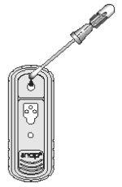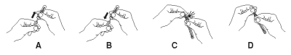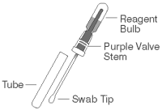swab, coat the swab tip with fecal material. Then, return the swab to the tube (B).

NOTE: Only a thin coat of fecal material on the swab is required; do not coat the swab with excess feces.

2. Break the purple valve stem inside the bulb assembly by bending the assembly at the narrow neck (C), re-bending the opposite way may be helpful. Squeeze the reagent bulb ***three times*** to pass the blue solution through the swab tip and mix it with the sample (D).

3. Place the SNAP device on a horizontal surface. Using the swab as a pipette, ***dispense 5 drops*** of the fluid into the sample well, being careful not to splash contents outside of the sample well.

The sample will flow across the result window, reaching the activation circle in 30-60 seconds. Some sample may remain in the sample well.

4. When color FIRST appears in the activation circle, push the activator firmly until it is flush with the device body.

NOTE: Some samples may not flow to the activation circle. Within 60 seconds if the sample does not each the activation circle, press the activator.

1. Read the test result at ***8 minutes***.

Interpreting Test Results

To determine the test result, read the reaction spots in the result window and compare the color intensity of the sample spot to that of the negative control spot.

**Positive Results**

Any color development in the sample spot indicates a positive result, and the presence of parvovirus antigen in the sample. It may be very faint and need to be held up to a light source.

**Negative Results**

Color development only in the positive co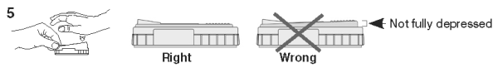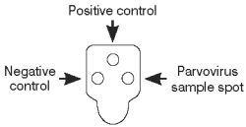ntrol spot indicates a negative result.

Invalid Results

● Negative control (safeguard against false-positives) - If color in the negative control spot is equal to or darker than the color in the sample spot, the result is invalid and the sample should be retested.

● No color development - If the positive control does not develop color, repeat the test.

● Background - If the sample is allowed to flow past the activation circle, background color may result. Some background color is normal. However, if colored background obscures the test result, repeat the test.

**Testing Positive - SNAP test is Positive**

When the SNAP test is positive, the litter remains the PL Ward, receives continued treatment as prescribed by the vet and is re-tested two days later.

**Testing Negative - SNAP test is NEGATIVE**

When the SNAP test is negative, the litter needs to leave the PL Ward as soon as a place can be arranged. This will depend on the age, weight, health, and eating status of the litter.

Kittens that are **6 weeks, weight 1.5 lbs (680g), and eating on their own** will go to the **Cat Program**. The Cat Program will determine where the kitten or litter will go depending on the health of the kitten/litter.

* Healthy kittens will go into the Cattery
* Kitten with ringworm will go to the Ringworm Cattery
* Kitten with Calici will go the the Calici Ward
* If the kitten has other health issues, the Cat Program will decide where it will go

**Kittens that do not go into the Cat Program must find fosters**.

**EMAILS**

The PL tech will send out emails to all the necessary programs at APA! to find who and when will take over care of the kitten once it leaves the PL Ward.

1. **Kittens going into the Cat Program**

* weight at least 1.5 lbs (680g) and
* age is at least 6 weeks and
* eating on own

**Email (keep emailing until a determination is made):**

[bbfostermanager@austinpetsalive.org](mailto:bbfostermanager@austinpetsalive.org) (Neonatal Foster Manager)

[cat-adoption-manager@austinpetsalive.org](mailto:cat-adoption-manager@austinpetsalive.org) (Cat Program Manager on Duty)

[panleuk.tech@austinpetsalive.org](mailto:panluek.tech@austinpetsalive.org) (Panleuk Tech, for a copy)

if the kitten(s) has ringworm, include

[ringworm-manager@austinpetsalive.org](mailto:ringworm-manager@austinpetsalive.org)

with the kitten(s) following information:

* Name
* Age
* Weight
* Health Information

1. **Kittens remaining in the Neonatal Program**

* under 1.5 lbs or
* less than 6 weeks of age or
* not eating on own

**Email (keep emailing until a determination is made):**

[bbfostermanager@austinpetsalive.org](mailto:bbfostermanager@austinpetsalive.org) (Neonatal Foster Manager)

[panleuk.tech@austinpetsalive.org](mailto:panluek.tech@austinpetsalive.org) (Panleuk Tech, for a copy)

with the kitten(s) following information:

* Name
* Age
* Weight
* Health Information

**Leaving the Ward**

How the kitten leaves the PL Ward depends on where it is going. If the kitten remains in the Neonatal Program, it will not go through the clinic for intake. If the kitten enters the Cat Program, but is sent to a quarantined ward (Ringworm, Calici), it will not go through the clinic for intake. Only healthy kittens going into the Cat Program (Cattery) will go through the Clinic for intake.

To the Cattery:

1. Kitten is bathed out, remains in portable crate on clean side of Parvo Ward
2. Cat Intake Record is filled out and posted in the Clinic
3. ShelterLuv is updated with new location of kitten in APA!
4. PL sheets are scanned and sent for ShelterLuv data entry
5. Make sure kitten is still not waiting for Clinic intake, Cat Program will come to the Clinic for transfer

To the Ringworm Ward (or other quarantined area in APA!):

1. Kitten is bathed out
2. Kitten is taken straight to the Ringworm Ward (no Clinic intake or intake form)
3. ShelterLuv is updated with new location of kitten in APA!
4. PL sheets are scanned and sent for ShelterLuv data entry

To Foster:

1. Kitten is bathed out, remains in portable crate on clean side of Parvo Ward (next to the Clinic door) until Foster comes for pickup (no Clinic intake or intake form)
2. ShelterLuv is updated with new location of kitten in APA!
3. PL sheets are scanned and sent for ShelterLuv data entry
4. Make sure kitten is still not waiting for Foster pickup. Reach out to Neonatal Program if Foster does not pickup.

To Panleuk Foster:

1. Panleuk Foster arrives for pickup
2. Kitten is not bathed out, but is passed to the PL Foster who has their own portable crate. PL Tech places the kitten(s) into the PL Fosters crate in the Parvo Ward changing area (from contaminated-side to clean-side)
3. ShelterLuv is updated with new location of kitten in APA!
4. PL sheets are scanned and sent for ShelterLuv data entry **AND** to the PL Foster

**Bathe out**

Bathing out kittens is done on the clean side of the Parvo Ward (area before the changing-into-scrubs-side). If you are inside the PL Ward, you will have to change out and leave the Ward to bathe out kittens. Communicate with the Parvo Manager, Parvo staff/volunteer, or Panleuk volunteer that kittens are getting bathed out and you will need their assistance in handing kittens to you. You will need the kittens’ information to properly fill out the **Cat Intake Record** for kittens needing intake. Take a picture of their forms so you will have the information when outside of the Ward.

Steps for bathing kittens:

1. Take a picture of the kittens’ information needed for the **Cat Intake Record** if the kittens must go through the Clinic’s intake. Since no papers can leave the Ward, you will need to you have this information when filling out the forms. You will need to do this while you are in the PL Ward.
2. Change out of the scrubs and leave the Ward
3. Go to the Cattery and laundry area to get enough clean portable crates and clean dry towels and bedding for the number of kittens getting baths.
4. Leave them at the sink just inside the Parvo Ward. Mark them with a note so no one else will use or take them if they are not going to be used immediately.
5. Turn the water on to a luke warm temperature, make sure there is shampoo, scrub brush, and nail clippers in the sink
6. Knock on the Parvo Ward wall to get the attention of someone inside the Ward so they can hand you a kitten. Bathe out one at a time.
7. Bathe the kitten paying close attention to paws, nails, whiskers, ears, butt. Rinse. Repeat the wash. Rinse.
8. Place in towel and clip nails
9. Dry well and place on clean, dry bedding in crate
10. Repeat for each additional kitten.
11. Keep litters in separate crates if bathing out more than one litter
12. Leave crates near sink for Foster pickup or Clinic intake, or take crates to destination if time permits.

**Clinic Intake**

For kittens going through Clinic intake:

1. Fill out **Cat Intake Record** form located in a vertical stack on the half, steel wall next to the sink. There are cat and dog intake forms mixed together.
2. Use the pictures you took with your phone to complete the form.
3. Fill out a form for each kitten
4. Enter the Clinic through the across from the sink
5. Clip the forms onto the Clinic/Parvo door using the designated clip the form and turn on the red light. Leave the same way you entered

**Cat Intake Record**

* Intake Exam for: Animal name
* ID#: APA # as found on the **APA! Parvo Ward Intake Form**
* Intake Date: The bathe out date(leaving-the-ward date)
* Originating Shelter: Shelter as found on the **APA! Parvo Ward Intake Form**
* DOB/Age: Date of b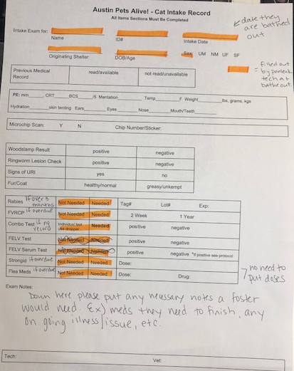irth if know / Age as of bathe out date
* Sex: Unaltered male, neutered male, unaltered female, spayed female
* Vaccination Records: Find from ShelterLuv
* Exam Notes: Anything that needs the Clinics attention; possible ringworm, wound, meds still need to finish

**Panleuk Charts**

These are the instructions for scanning and emailing the charts (**Treatment** and **Daily Care** sheets) to the APA! data entry staff for Shelterluv. These instructions come from the prior Parvo Manager, Steve Porter.

It is long and seems complicated. Practice and then it will be much easier than it seems.

Protocol will be as follows:

1. Prior to bath out, the charts should be scanned using your smartphone and a scanning app, CamScanner.  Sheets should be scanned with intake form first and then each treatment sheet earliest to latest.  The treatment sheets should be scanned with a horiz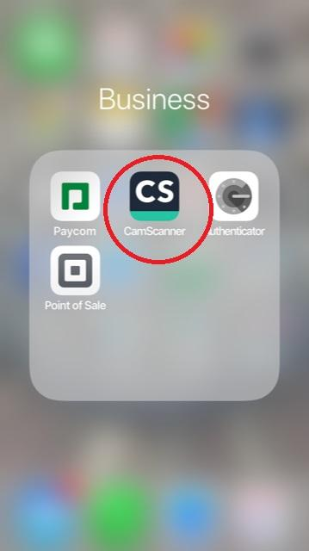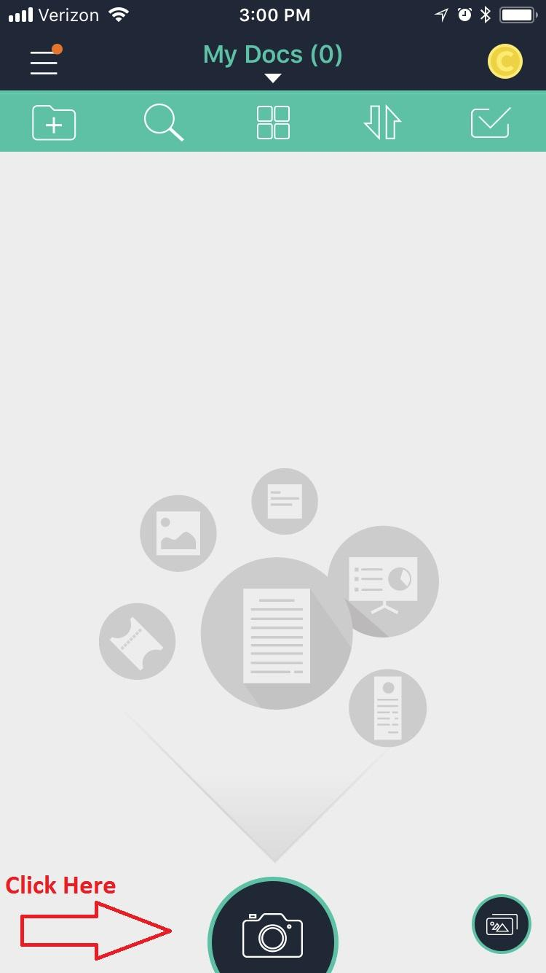ontal layout.
2. The file should be named ParvoPanleukNotes_(Kitten’s name & litter #)_(Shelterluv #).pdf. For example ParvoPanleukNotes_Galileo22_62534.pdf
3. **Mail the file to**

**Parvo Manager <**[**parvo.manager@austinpetsalive.org**](mailto:parvo.manager@austinpetsalive.org)**>**

**Medical Reception Apa <**[**medicalreception@austinpetsalive.org**](mailto:medicalreception@austinpetsalive.org)**>**

**Melissa Keys <**[**melissa.keys@austinpetsalive.org**](mailto:melissa.keys@austinpetsalive.org)**>**

**Panleuk Tech <**[**panleuk.tech@austinpetsalive.org**](mailto:panleuk.tech@austinpetsalive.org)**>**

1. DO NOT through away the treatment sheets.  There is a box on top of the shelves labelled treatment sheets...please put them in there.  We will be keeping sheets for a 3 month period.

All sheets should be scanned and emailed within 24 hours of the discharge.

When you open it this is what you see. You then click on the camera icon to start.

Take a photo of the page to be scanned:

Use Batch option if scanning either a single page or a multi page.

Edit the photo you scanned by clicking on the photo itself. You will do this after each photo you take whether it be a single page scan or multi page scan.

You will need to crop and rota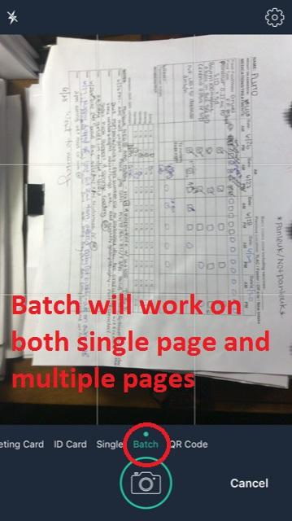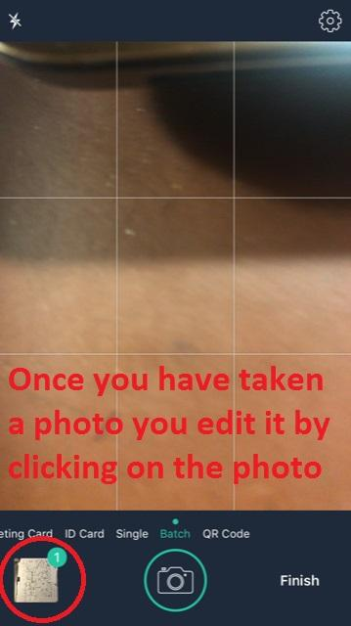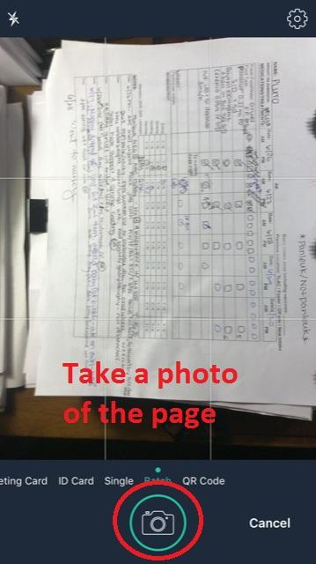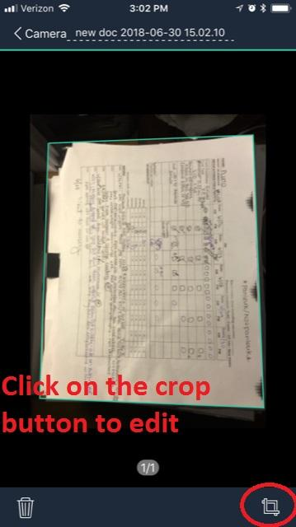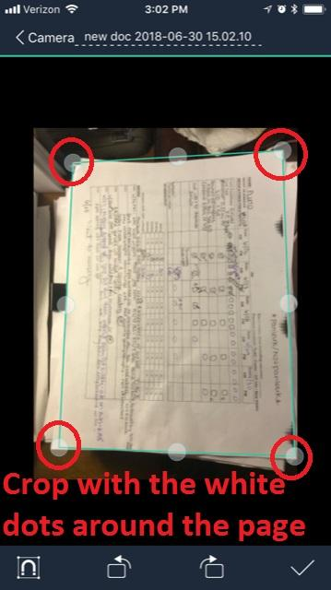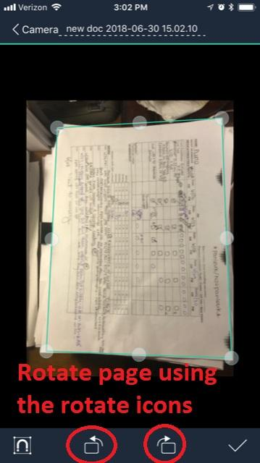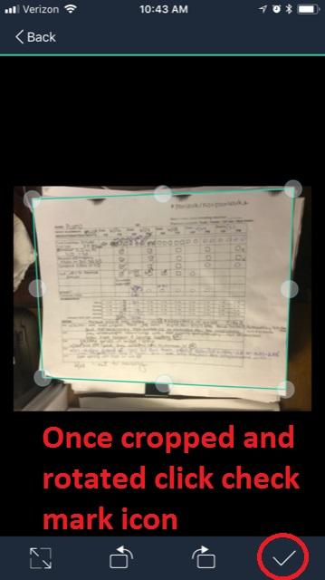te each photo.

Crop the photo if necessary by sliding the little white dots to where you want the edges of the scan to be.

How to rotate the photo is in the next step.

No you need to save the changes you made when you edited the photo. Click on the check mark in the lower right corner.

Now you need to click on the camera icon whether you want more page scanned or if this is the only page. (the photo should have been rotated but I used the wrong screen shot when labeling this one)

When you are done editing each page, if there are multiple pages or just one page, you need to click on the finish icon to rename and email.

The next steps are to rename the file. Click on the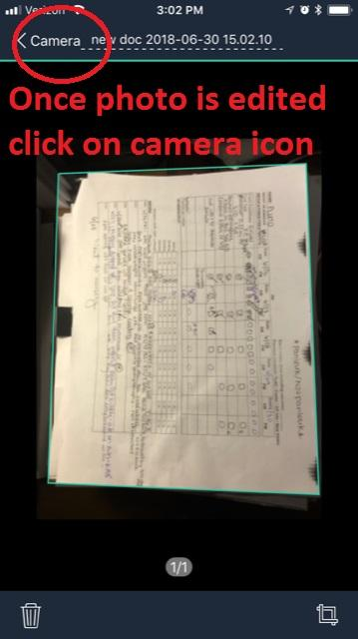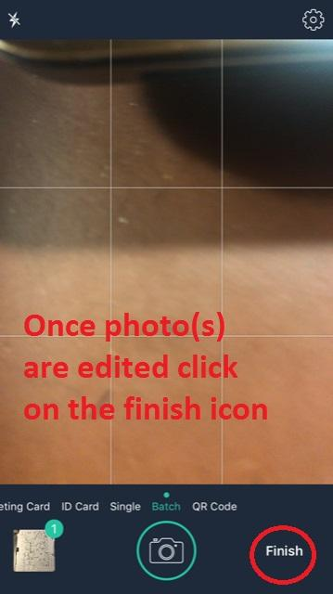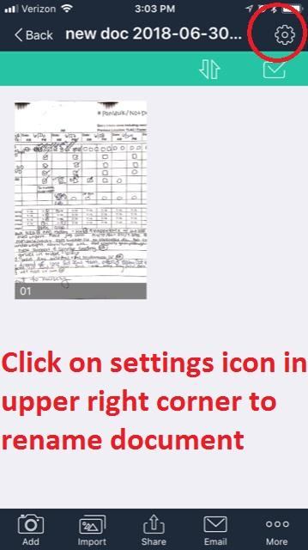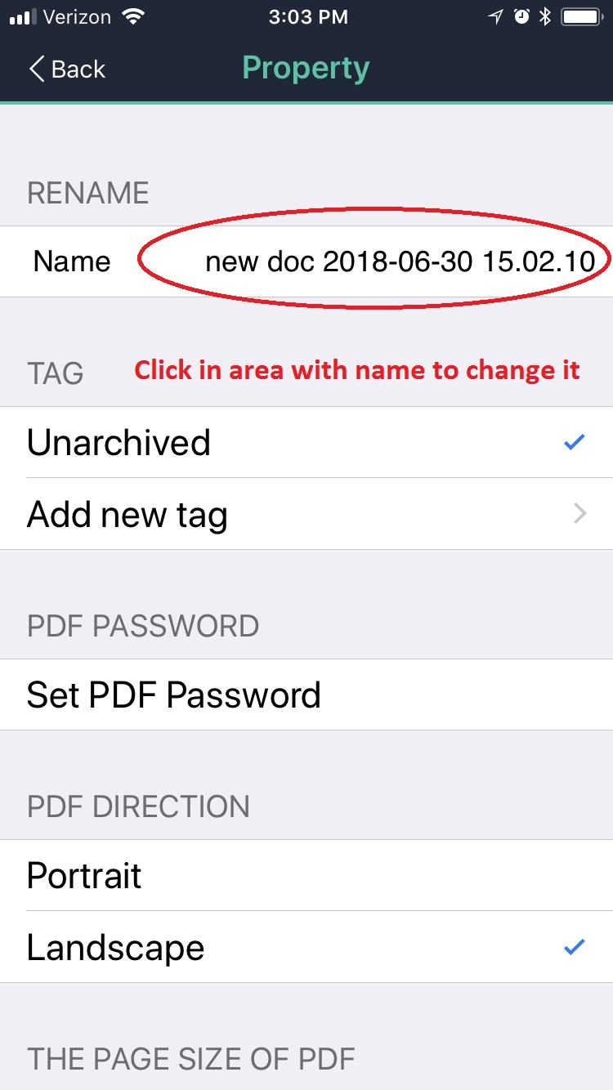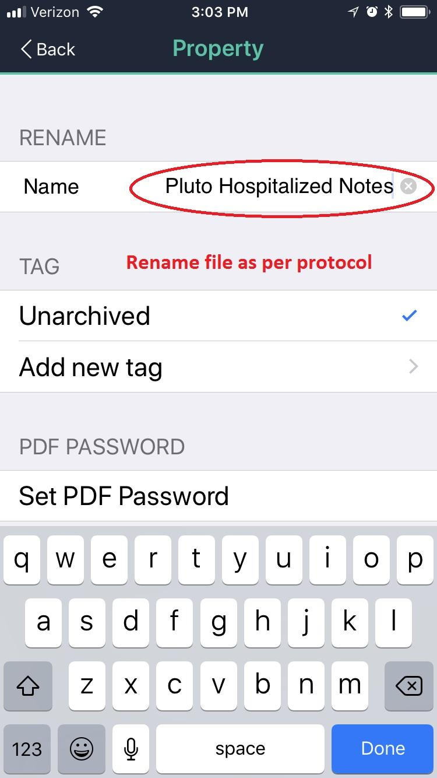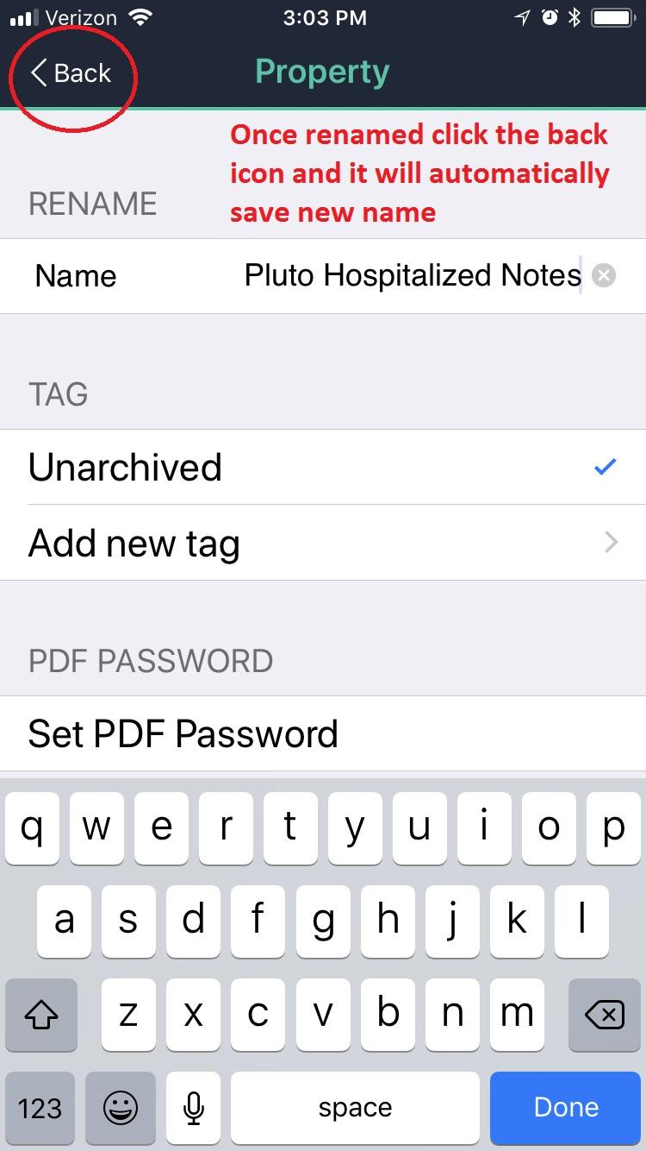 setting icon in the upper right corner.

The next screen will look like this. Click inside the name area. A small 'x' will appear to the far right of the name. You can either delete the defaulted name by clicking the 'x' or hitting the delete key on your keyboard.

Rename the document as per protocol.

Once it is renamed you have to click the back button in the upper left corner.

Click on the check mark icon in the upper right hand corner to create a multi page file.

Next click on the select all icon.

This will highlight all the pages with green check marks.

After all pages have the green check marks you click the email icon at the bottom of the scree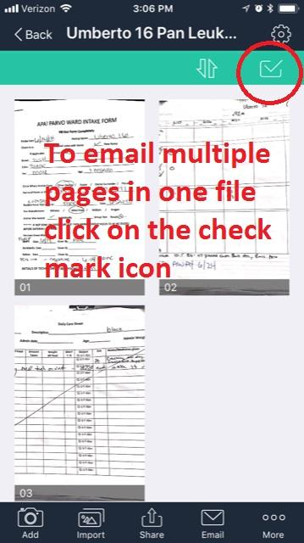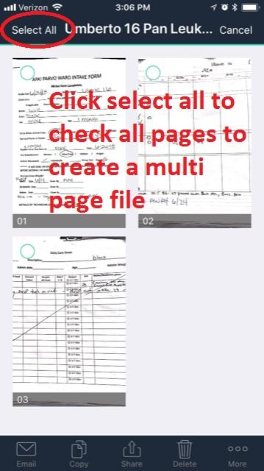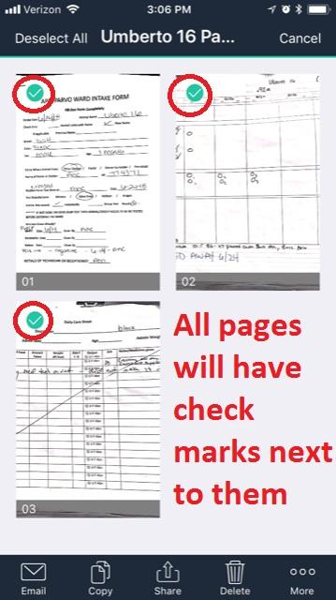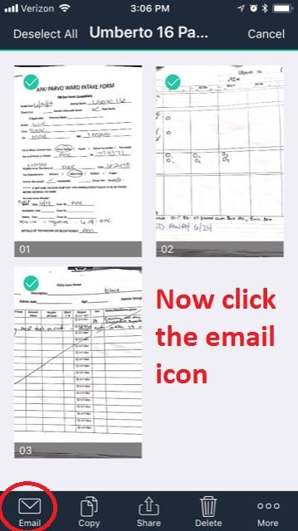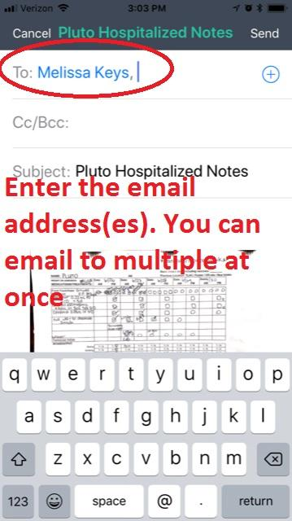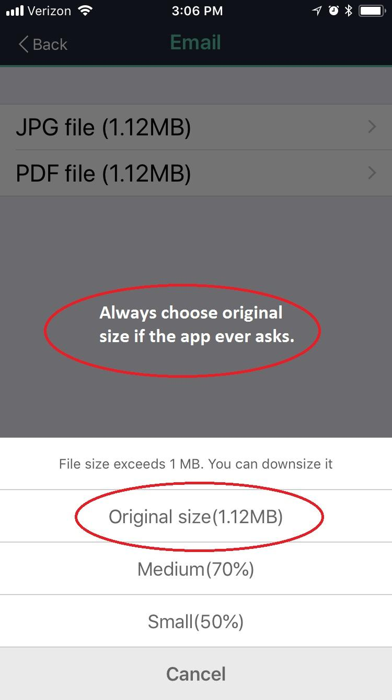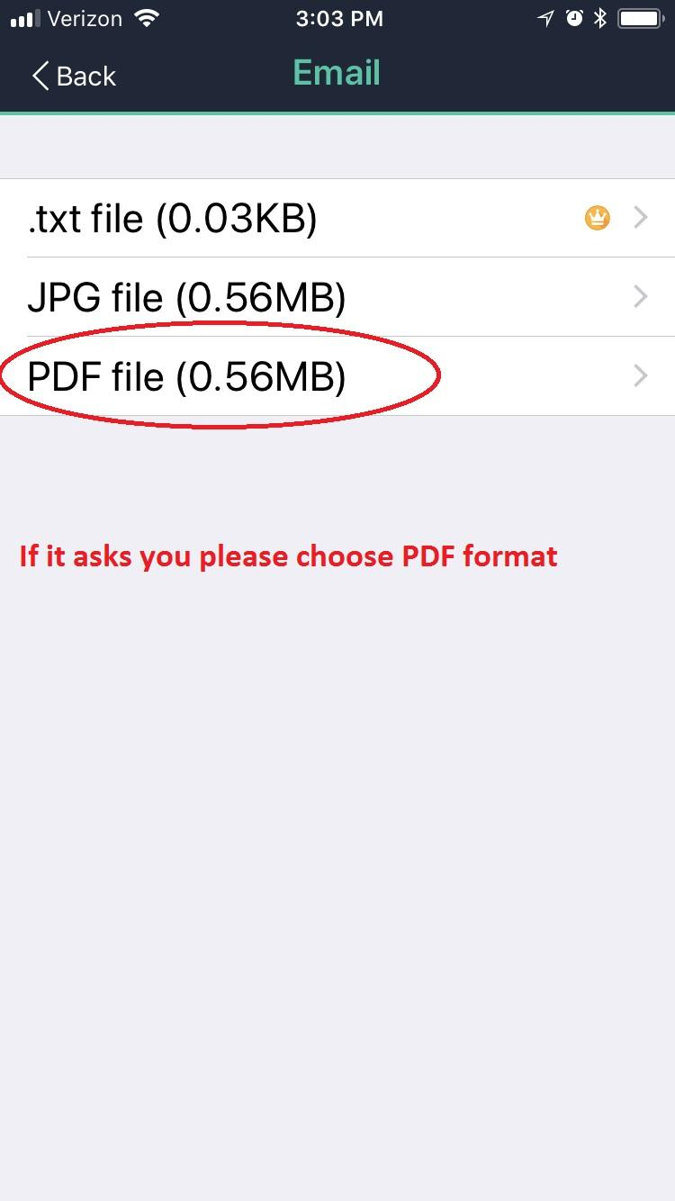n

Type in email address(es) and click send.

Once you click send it will usually ask you to choose the size. Always choose original size when prompted please.

Choose PDF file type. The screens of a single page file and multi page file may looks a bit different from each other.

**SUPPLIES**

Before going into the PL Ward, scan the TLAC donation drop-off area for items needed in the Ward; litter, toys, plates, bowls, food, puppy pads, etc. Sometimes you can find items before you have to make a plea for them. Plus, it saves on supplies taken from the Nursery.

**Can Food**

Can cat food used in the Neonatal Nursery is the same food used to make gruel and syringe gruel in the PL Ward. The instructions and mixture are the same as the Nursery.

When the shipment of can food arrives for the Nursery, it arrives at TLAC first and is put into the unused dog runs across from the Barn Cat enclosures. You can pull food from this location while it remains at TLAC. The entire shipment of can food is taken to the Nursery as soon as transport is arranged. The dog run gates are chain locked. **The code: 1515.**

Other can cat food can be fed to older kittens (over 2lbs) and adults to entice eating. The Cattery has a variety of can foods and the TLAC donation drop-off area will occasionally have donated cat food from which to choose.

Pleas to the PL volunteer feeders for cans of plain chicken can go on the PL Shift Report. Small amounts can be used to entice eating.

**Dry Food**

Dry kibble food used in the Neonatal Nursery is the same dry kibble food used in the PL Ward. Kittens should be given a small amount of kibble as not to waste it.

Kibble can be from the Nursery or pleaded for on PL Shift Reports. Regular dry food can be given to the older kittens (over 2lbs) and adults. The TLAC donation drop-off area will occasionally have donated dry cat food from which to choice.

**Litter**

Litter used in the Neonatal Nursery is more often the same litter used in the PL Ward. Always use the non-clumping litter for kittens.

The litter for the Neonatal Nursery is kept at TLAC in the unused dog runs marked Neonatal Only across from the Barn Cat enclosures. You can pull litter from this location while supplies last. The dog run gates are chain locked. **The code: 1515.**

If there is non-clumping litter at the TLAC donation drop-off area, you can use that also.

**COMMON TERMS**

**Condition:**

**BAR: bright, alert and responsive**

BPM: beats or breaths per minute

CBC: complete blood count

D+: diarrhea

HR: heart rate

NSF: no significant findings

PU/PD: polyuria/polydipsia (i.e., drinking and urinating more than normal)

PTS: put to sleep (euthanasia)

**QAR: quiet, alert and responsive**

QOL: quality of life

ROM: range of motion

RR: respiratory rate

S/R: suture removal

Sx: surgery

TPR: temperature, pulse and respiration rates

UA: urinalysis

URI: upper respiratory infection

UTI: urinary tract infection

WNL: within normal limits

**Med delivery:**

**BID: twice daily, every 12 hours**

EOD: every other day

D/C: discontinue

IM: intramuscular

IN: intranasal

IV: intravenous

NPO: nothing by mouth

**PO: by mouth, orally**

PRN: as needed

QD: once daily, every 24 hours

QID: four times daily, every 6 hours

QOD: every other day

**SC, SQ, SubQ: under the skin**

**SID: once daily, every 24 hours**

STAT: immediately

**TID: three times daily, every 8 hours**

**Historic Misc. Items**